**Objective:**

**The goal of this week is to practice queries on Aggregate functions like count, max, min, avg, sum and practice queries like nested queries/co- related queries using ANY, ALL, IN, Exists, NOT EXISTS, UNION, INTERSECT, group by and having etc.**

**Task1: Aggregate Functions**

**Consider the following database tables and write the solution for the given queries.**

**Tables: Employee (eid, ename, salary, doj, comm, did) Department (did, departmentname, location)**

**Sample data in Employees Table:**

|  |  |  |  |  |  |
| --- | --- | --- | --- | --- | --- |
| eid | ename | salary | doj | comm | did |
| 106 | Jim Halpert | 48000 | 2017-09-18 | 400 | 10 |
| 107 | Stanley Hudson | 52000 | 2016-02-23 | 550 | 20 |
| 108 | Phyllis Vance | 46000 | 2015-08-11 | 350 | 30 |
| 109 | Angela Martin | 54000 | 2014-07-07 | 600 | 10 |
| 110 | Kevin Malone | 44000 | 2013-05-15 | 250 | 20 |
| 111 | Meredith Palmer | 40000 | 2012-03-28 | 150 | 30 |
| 112 | Andy Bernard | 56000 | 2011-01-10 | 700 | 10 |
| 113 | Darryl Philbin | 50000 | 2010-12-01 | 450 | 20 |
| 114 | Oscar Martinez | 58000 | 2009-11-17 | 800 | 30 |
| 115 | Toby Flenderson | 42000 | 2008-10-22 | NULL | 10 |
| 116 | Jane Smith | 62000 | 2012-03-28 | 400 | 20 |
| 117 | Alice Brown | 75000 | 2011-01-10 | 550 | 10 |
| 118 | Bob Davis | 48000 | 2010-12-01 | 350 | 30 |
| 119 | Carol White | 67000 | 2009-11-17 | 600 | 40 |

**Sample data in Department Table:**

|  |  |  |
| --- | --- | --- |
| DID | DepartmentName | Location |
| 10 | HR | New York |
| 20 | Finance | London |
| 30 | IT | San Francisco |
| 40 | Marketing | Chicago |

**Q1).  Write a query to Count the number of employees in each department.**

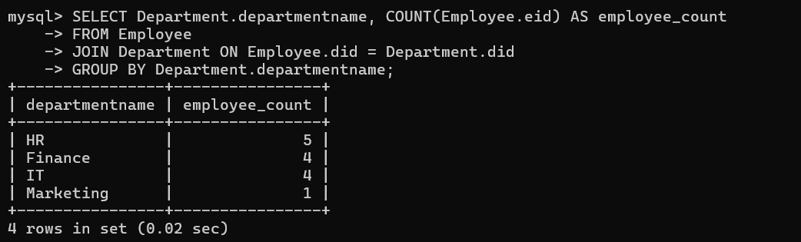**Q2). Write a query to Find the maximum salary in the company.**

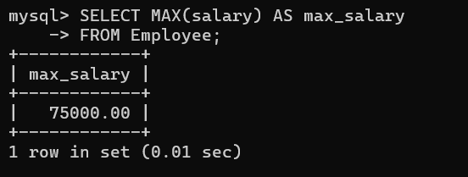

**Q3). Write a query to Find the minimum salary in each department.**

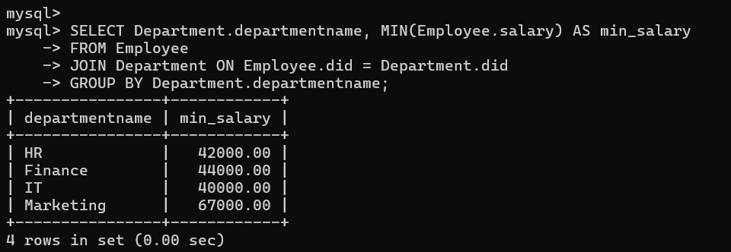

**Q4). Write a query to Calculate the average salary of employees.**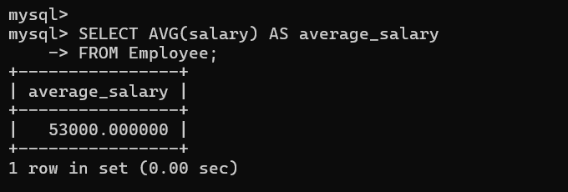

**Q5). Write a query to Sum the total salaries of all employees.**

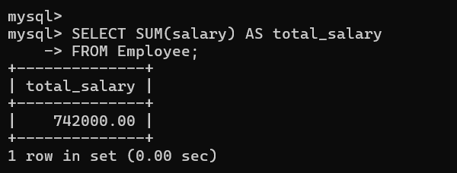

**Q6). Write a query to Count the number of employees in each department, but only for departments with more than 5 employees.**

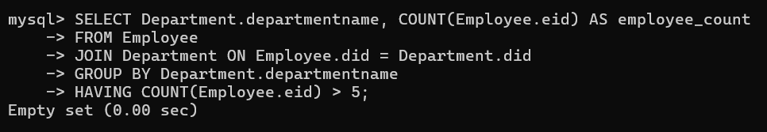

**Q7). Write a query to Find the average salary for each department, but only include job titles where the average salary is greater than 60,000.**

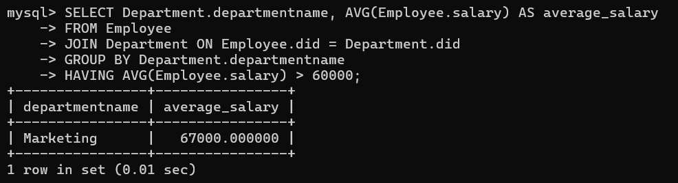

**Q8). Write a query to Find the department with the second highest average salary.**

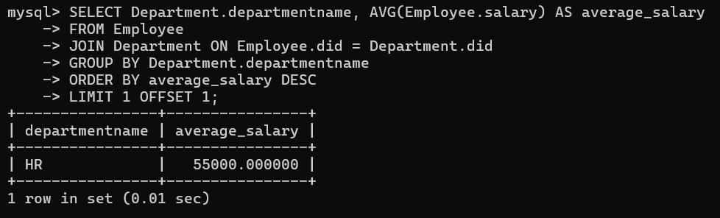

**Q9). Write a query to Find the employee who has the third highest salary in the company.**

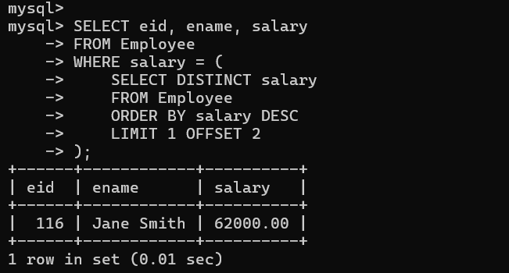

**Q10). Write a query to Union of employees from department 10 and department 20.**

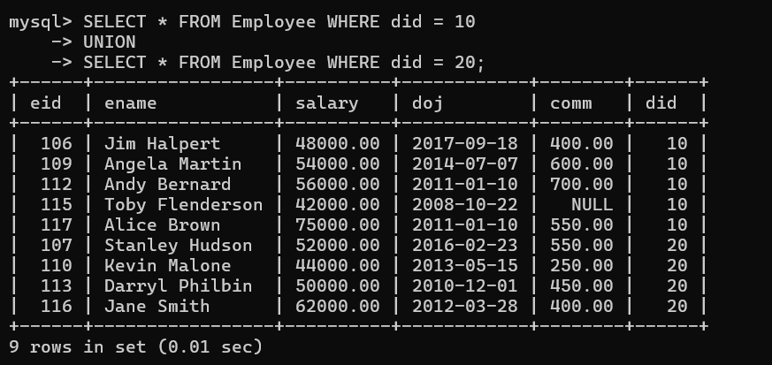

**Q11). Write a SQL query to identify employees who both work in department 10 and have a salary greater than 60,000.**

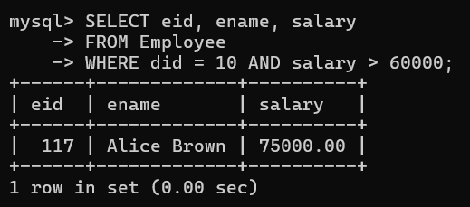

**Q12): Find the average salary of each department, but exclude departments where the minimum salary is less than 30,000.**

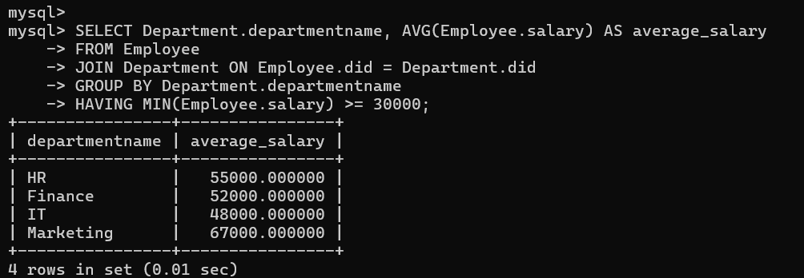

**Q13): Find the total number of employees for job titles where the total salary paid is within 10% of the maximum salary paid for that job title.**

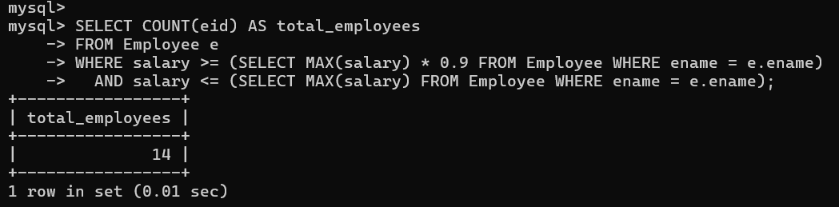

**Q14): Find the department where the difference between the highest and lowest salaries is the largest.**

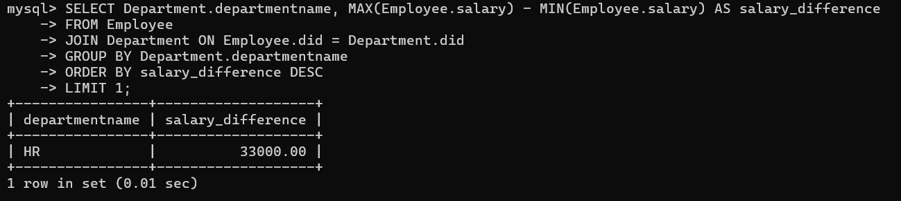

**Task2. Nested and Correlated Queries**

**Consider the following database tables and write the solution for the given queries Using ANY, ALL, IN, EXISTS, NOT EXISTS, UNION, INTERSECT.**

**Tables: Employee (eid, ename, salary, doj, comm, did) Department (did, dname, location)**

**Q15) Write a query to Find employees who earn more than the average salary:  
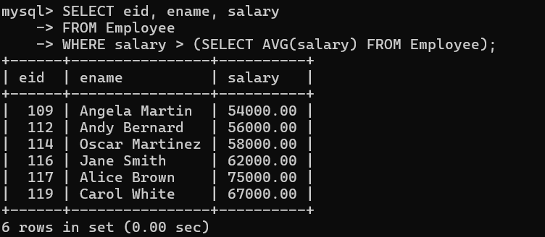**

**Q16). Write a query to Find departments that have more employees than the average department.**

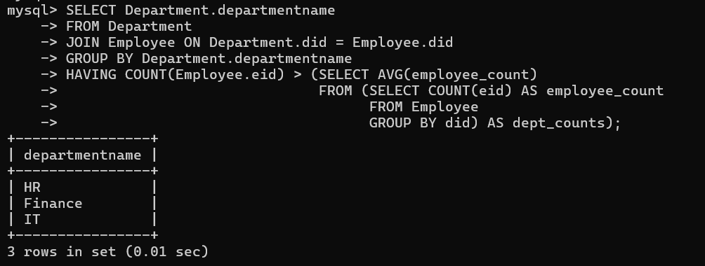

**Q17). Write a query to Find employees whose salary is greater than the salary of all employees in department 20**

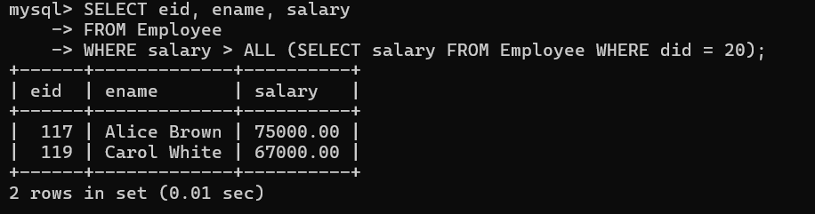

**Q18). Write a query to Find employees who earn more than anyone in department 10.**

**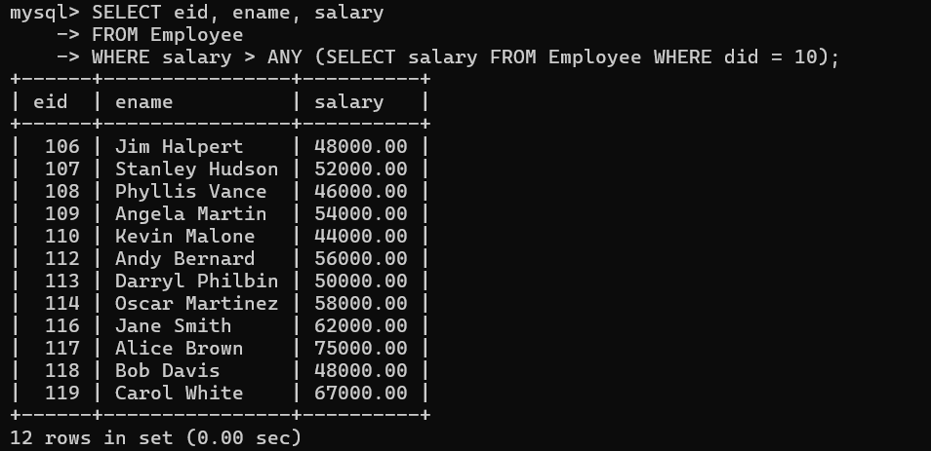  
  
Q19). Write a query to Find departments that have at least one employee with a salary greater than 50,000.**

**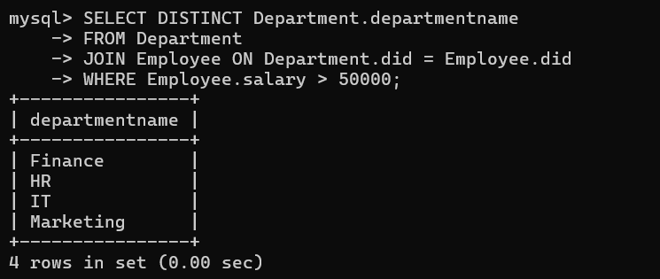  
  
Q20). Write a query to Find departments that do not have any employees with a salary greater than 50,000.**

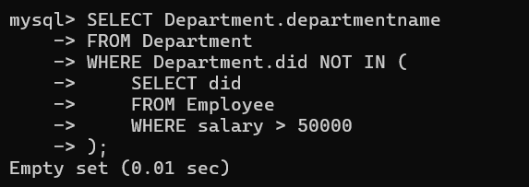

**Task3: Nested and Correlated Queries for the University System**

**Consider the following database tables and write the solution for the given queries Using ANY, ALL, IN, EXISTS, NOT EXISTS, UNION, INTERSECT.**

**Sample Data for University System**

**Student (sid, sname, ccode, dob, address)**

**Course (ccode, cname, did, fees)**

**Department (did, dname, location)**

**Faculty (fid, fname, sal, designation, doj, did)**

**Nested Queries for the University System**

**Q21: Find students who have enrolled in courses offered by a specific department.**

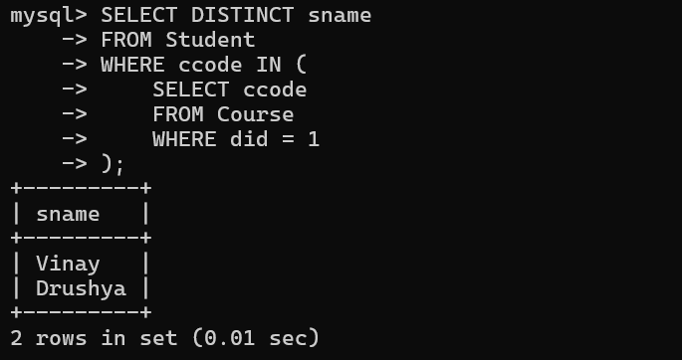

**Q22: Find the names of faculty members who teach courses that have a fee greater than the average course fee.**

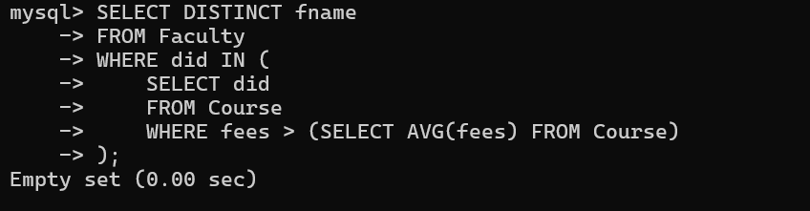

**Q23: Find the names of students who have enrolled in all courses offered by a specific department.**

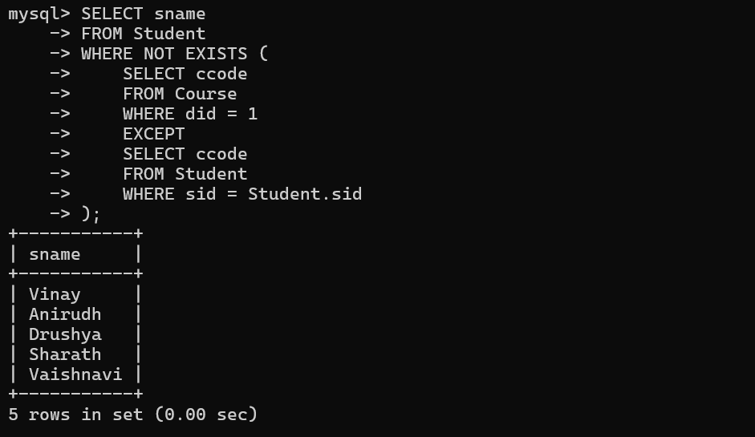

**Q24: Find the names of departments where the average faculty salary is higher than the average student's course fee.**

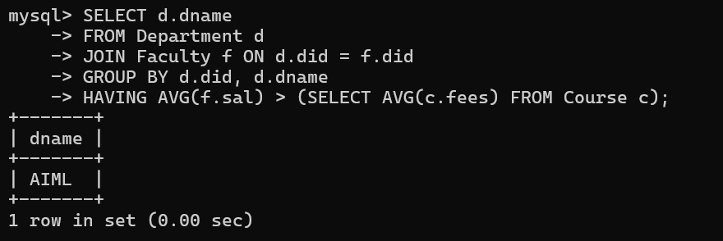

**Q25 Find the names of students who have enrolled in courses taught by faculty members with a salary greater than the average faculty salary.**

